Final Assignment:
To do list:
- Go through the instructions for the assignment on Canvas and check that the your text meets those requirements and that you understand what your text will be graded on.
- Have a good look at the feedback on any earlier assignments in the course and make sure that you incorporate that feedback into this final assignment.
- Make sure you proofread your text carefully for typos, grammar and vocabulary errors, and obvious formality errors such as ‘you’ and verb contractions.
- Go through the items on the following checklist to make sure your document meets all requirements.
Checklist:
- Your name and student number are on the first page.
- The first page contains the title of your text.
- The text doesn’t have any section headings.
- The text has the required length (not including bibliography).
- The text has the required paragraph structure:
  - Every paragraph has a topic sentence, followed by the elaboration.
  - All paragraphs have roughly the same length (i.e. no one-sentence paragraphs, no subparagraphs).
  - The introduction is one paragraph.
  - The final sentence of the introduction contains the thesis statement, which may also take the form of a question (or statement of your aims, or research question).
  - The conclusion is one paragraph.
- You have use the required number of academic sources in the text.
- You have indicated the sources correctly and consistently throughout the text, using an appropriate referencing style.
- You have included a full bibliography.
- The layout settings meet the following requirements:
  - Use 1.5 spacing and standard font type and size.
  - Indent each paragraph, except the first one.
  - Don’t use any extra line spaces between paragraphs (see point 12 below for details).
  - Keep the layout of the document as basic as possible (standard margins, standard font, no colours)
- Your assignment can be handed in as a word document (NOT pdf, odt, …).
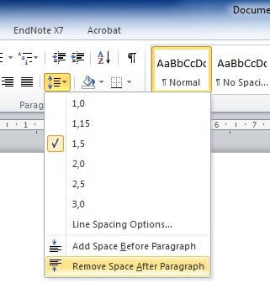
- If the Word version you are using has a standard extra space/white line after paragraphs, you need to remove this so that the space between lines between two paragraphs is identical to the space between lines within a paragraph. You can change this setting as shown in the following picture.

